Manchester and District
Ladies’ Cycling Association

24th July 2021

Ladies Open Handicapped, Men’s Invitation and GHS 10 mile Time Trials
Promoted for and on behalf of Cycling Time Trials under their Rules & Regulations.
Handicapped using standard tables, using fastest time since 1st Jan 2020, or if none ridden, fastest time in last 3 years.

Event Organiser: Heather West, 49 Grendale Avenue, Hazel Grove, Stockport, Cheshire, SK7 6LJ
Tel: 07800854203
Timekeepers: Mr M Jackson & Mr I Ross First rider off at 2:01 pm
Headquarters: Goostery Village Hall Car Park postcode CW4 8PE located in Goostrey Primary School on Main Road, Goostrey.
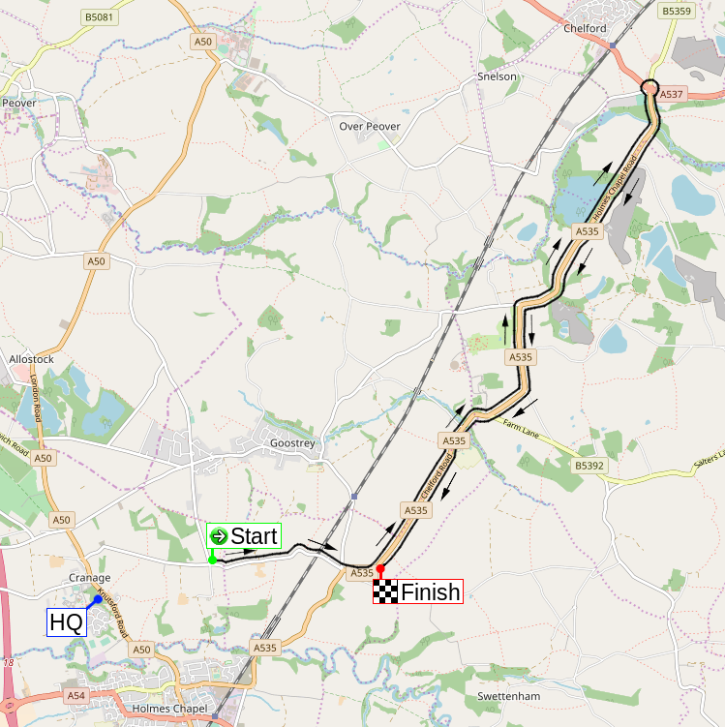
Signing on and collection of numbers will be in the entrance vestibule with numbers available from a table from 12.30pm onwards, please bring your own pen. Please note each rider must sign-on when collecting their number, and sign-off when returning it. Failure to do so will result in that rider being classified as DNF.
Directions from headquarters to start, and from finish back to headquarters
The route will be signposted, please allow plenty of time to cycle to the start which is approx. 1.5 miles from the HQ.
To the Start – turn left onto Main Road, continue for approx. 1 mile and turn left onto Hermitage Lane (signed). At the crossroads turn left. The start is on your left.
To return to the HQ at the end of the time trial, continue on past the finish and turn right, with care, back into Twemlow Lane. Turn first right onto Goostrey Lane and continue back to HQ after approx. 1 mile on left.

Course details: J2/3 – 10 miles
START 0.000 m
In Twemlow Lane at a JS4 mark just east of Hermitage Lane in line with the
hedge on Hermitage Lane.
Proceed eastwards to the A535 at
TWEMLOW GREEN 1.047 m
Left along the A535 to
CHELFORD ISLAND 5.661 m
Encircle the island and retrace along the A535 to
FINISH 10.000 m
at a JF4 mark by the far post of the last field gate on the left of A535 at Twemlow Green before the Yellow Broom Restaurant

Prizes
Ladies |  |  |  |  | Men |  |  | Combined
1st | £30.00 | 1st handicap | £25.00 |  | 1st | £30.00 |  | 1st | £25.00 each
2nd | £25.00 | 2nd handicap | £20.00 |  | 2nd | £25.00 |  | 2nd | £20.00 each
3rd | £20.00 | 3rd handicap | £15.00 |  | 3rd | £20.00 |  | 3rd | £15.00 each

Certificate to be awarded to fastest M&DLCA Vet on standard at Annual Dinner.

One rider one prize, except Combination.

Covid Precautions
CTT has issued two PDF documents, a Covid-19 Risk Assessment and “Putting on a Cycling Time Trials Event during COVID19”. If you haven’t already read these, please download from the CTT website and read them carefully. These are the key messages: -
- Competitors should not attend if they feel ill in ANY way especially if they or family members have any Covid19 symptoms.
- Vehicle parking is provided at Goostrey Village Hall.
- The Village Hall building will be operated on a one-way system for access to the toilet area.
- There are men’s and women’s toilets: one in – one out, wear a mask and queue outside 2 metres apart if necessary. Users will have to apply hand sanitizer on entry.
- There are no changing facilities at the HQ, please come dressed ready to ride.
- Riders will sign-on at a table in the vestibule of the hall. Please bring your own pen.
- No more than THREE riders are allowed to queue at the start, so time your arrival accordingly or wait on Hermitage Lane suitably spaced until your turn.
- Do not leave any clothing, bottles etc at the start.
- No assisted push-off. Riders will have to set off unassisted from the Start timekeeper. Do not cross the start point until you get the signal from the timekeeper.
- There are no HQ catering facilities. Please bring your own post-ride recovery snacks and drinks.
- There is no public display Results Board, results will be available on the CTT website after the event. Please return to HQ promptly to sign out with your own pen, and return your number. Then please go home and do not congregate.
- Do not approach the timekeepers or any other officials.

Notes and Local Regulations
The Risk Assessment document will be available at Signing-On but we highly recommend you read this, in advance, on the CTT District website (https://manchester.ctt.org.uk/ ) – especially those riders who are not familiar with the course and its junctions (plus its ruts and potholes).

Care at road junctions
Riders must exercise care at all junctions. Any competitor whose riding line causes him/her to cross the white line when approaching or leaving a junction will be liable to disqualification and may be reported to the District Committee for further disciplinary action.
At give way junctions (such as turning left from Twemlow Lane onto the A535) riders must avoid traffic on the major road and stop if it is unsafe to proceed.

Chelford Island
Riders must negotiate Chelford Island in a safe and sensible manner in accordance with CTT Reg. 20 and the rules of the road. Riders must be able to brake and stop at the island if traffic conditions require this. Riders MUST NOT approach and encircle the island using tri-bars. Remember - traffic on the island has priority over traffic (including riders) entering it. Any rider seen to be in breach of this regulation will be disqualified from the event and may be reported for further disciplinary action.

Safe riding
Riding with your head down such that you do not have a good view of the road ahead is dangerous - please watch out for potholes, obstacles, and other road users.
Marshalls do not have the authority to control other road users, so please take care.

Start and finish
No “U” turns in the vicinity of the start or finish.
Riders must not stop at the finish, but should instead continue along the A535 to Twemlow Lane (take care when turning right from the A535 onto Twemlow Lane), then back to the headquarters.

Vehicles
A competitor must not be preceded, accompanied, followed by or in any way receive assistance from a motorised vehicle or its occupants during events shorter than 100km (CTT Reg 22).
No parking for riders or spectators at the start or finish. This is both for the safety of riders at the start, and because of limited space. Parking is available at the headquarters, please be considerate towards local residents.

Helmets
It is strongly advised for your own safety that you wear a hard-shell helmet that meets an internationally accepted safety standard.
All competitors who will be under the age of 19 on 31st December of this year MUST wear a properly affixed helmet of hard/soft shell construction. For these riders, a helmet is required (CTT Reg 15), instead of just strongly advised.
Rear Light
CTT Reg 14(i) No competitor shall be permitted to start either a Type A or Type B event unless such competitor has affixed to the rear of their machine a working rear red light, either flashing or constant, that is illuminated and in a position that is clearly visible to other road users.

Other notes
A competitor overtaking another must pass without receiving or giving shelter. The onus of avoiding company riding shall be upon the rider overtaken. (CTT Reg 21)
Riders should not warm up on the course after the event has started.

GHS
No. | Name | Cat | Club | Start
1 | William Coles | J | VMCC | 14:01
2 | Hebe Picking | J | Ilkley CC | 14:02
3 | Megan Lloyd | J | Harry Middleton CC | 14:03
4 | Alex Coles | J | VMCC | 14:04
5 | Nicholas Smith | J | Westmead Team 88 | 14:05
6 | Xavier Teece-Round | J | Innovation Racing | 14:06

Ladies
No. | Name | Cat | Club | H/Cap | Std | Start
10 | Hayley Rutherford | S | Manchester Bicycle Club | n/a |  | 14:10
11 | Sue Carter | V | ABC Centreville | n/a | 29.35 | 14:11
12 | Lynsey Astles | V | Congleton CC | 7.08 | 26.31 | 14:12
13 | Jenny Castle | V | Salford Cycling Club | 15.55 | 27.30 | 14:13
14 | Maddi Smith | V | Bolsover and District CC | 11.23 | 28.44 | 14:14
15 | Lesley Norbury | V | Congleton CC | 11.12 | 31.50 | 14:15
16 | Kerry Gleave | V | Congleton CC | 10.08 | 30.01 | 14:16
17 | Adele Reynolds | S | Macclesfield Wheelers | 9.49 |  | 14:17
18 | Alison Stephenson | V | Congleton CC | 8.34 | 28.44 | 14:18
19 | Jeanette Barber | V | Seamons CC | 9.02 | 31.22 | 14:19
20 | Gail Lowe | V | Congleton CC | 6.56 | 28.57 | 14:20
21 | Claire Harrison | V | Congleton CC | 6.55 | 27.54 | 14:21
22 | Sally Cunliffe | V | Ruthin Cycling Club | 6.04 | 31.36 | 14:22
23 | Emily Martin | S | Weaver Valley CC | 4.40 |  | 14:23
24 | Charlotte Boothman | S | Team Lusso | 3.48 |  | 14:24

Men
No. | Name | Club | Invited By | Start
25 | Philip Hoyle | Salford Cycling Club | Sue Carter | 14:25
26 | David Steele | Lyme Racing Club |  | 14:26
27 | Martin Ince | Salford Cycling Club |  | 14:27
28 | Martin Pye | Team TFC |  | 14:28
29 | Paul Barber | Seamons CC | Jeanette Barber | 14:29
30 | Rob Hallam | South Pennine RC |  | 14:30
31 | Len Best | Matlock CC | Maddi Smith | 14:31
32 | Tim Smith | Westmead Team 88 |  | 14:32
33 | Philip Gleave | Congleton CC | Claire Harrison | 14:33
34 | Adrian Fox | Congleton CC | Lesley Norbury | 14:34
35 | Duncan Poole | Congleton CC | Kerry Gleave | 14:35
36 | David Tobin | Manchester Wheelers |  | 14:36
37 | Robbie Harcourt | Salford Cycling Club | Jenny Castle | 14:37
38 | Kevin Milward | Congleton CC |  | 14:38
39 | Mick Hutchins | Congleton CC | Lynsey Astles | 14:39
40 | Nigel Finch | Mercia-Lloyds Cycles CC |  | 14:40
41 | Peter Rogers | Chorlton Velo |  | 14:41
42 | Graham Howell | Element Cycling Team |  | 14:42
43 | Jonathan Lloyd | Westmead Team 88 | Adele Reynolds | 14:43
44 | John Spearman | Seamons CC |  | 14:44
45 | Lior Saard | University of Manchester CC |  | 14:45
46 | Jac Gruffydd | Caffi Gruff | Sally Cunliffe | 14:46
47 | Robert Pollen | Ashley Touring CC |  | 14:47
48 | Russell Horner | Team Sports Lab |  | 14:48
49 | Benjamin Williams | Cliff Pratt Racing |  | 14:49
50 | Andrew Hicklin | Peak Road Club |  | 14:50
51 | James Brayford | Lyme Racing Club | Gail Lowe | 14:51
52 | Mat Stephenson | Congleton CC | Alison Stephenson | 14:52
53 | Stephen Dooley | Seamons CC |  | 14:53
54 | James Foggensteiner | Team PB Performance | Charlotte Boothman | 14:54
55 | Alistair Rutherford | Manchester Bicycle Club | Hayley Rutherford | 14:55
56 | Alexander Royale | Manchester Bicycle Club |  | 14:56
57 | Adam Duggleby | Chapeau! Vive Le Velo | Emily Martin | 14:57

M&DLCA
Other M&DLCA events 2021 – see CTT website for further details, entries on-line, closing dates 10 days before event.

Course | Date & time | Organiser | Information
J2/9  25 miles | Saturday 7th Aug  14:00 | Mavis Ross | (in conjunction with Weaver Valley)
J4/9  50 miles | Sat 4th Sept  13:00 | Ian Ross | M&DLCA open championship 50 (in conjunction with M&DTTA championship. All riders should enter the M&DTTA event)

Each year, the M&DLCA awards several prizes and trophies to members of the M&DLCA and affiliated clubs. Clubs can affiliate by sending £10 affiliation fee to Mavis Ross, details are on our website on the affiliation form. Any event on a ‘25’ or ‘50’ mile ‘J’ course counts for these trophies, as long as copies of the results sheet and entry form are sent to the M&DLCA BAR Secretary, K. Jackson, but the only counting ‘10’ mile events are those organised by the M&DLCA, plus, for this year only, the 10 mile event on 9th October 2021 being run by the M&DTTA. This is because we had to cancel one of our own 10 mile events due to COVID restrictions.
The onus is on the rider to submit, where required, copies of the entry form and results sheet to the M&DLCA BAR Secretary before 1st October of the current season.

Visit our website at http://www.mdlca.org.uk for the latest news, results and photos
We also have a Facebook page for photos and posts, and on Twitter we are @ManDLCA.

